11/6/2021

Babalwa.Mpunyuka@womentechsters.org

BABALWA MPUNYUKA

PRACTICAL ACTIVITY 4

Practical Activity 4

**Creating auntentic.sh script and nano editor code**

I have created a file script auntentic.sh and used the nano editor to write my code. See attached screenshot below.

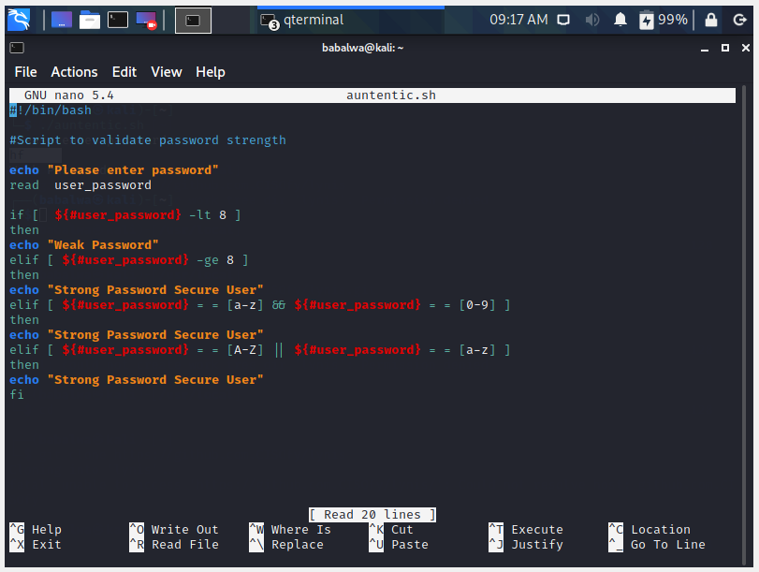

**Testing different passwords**

* 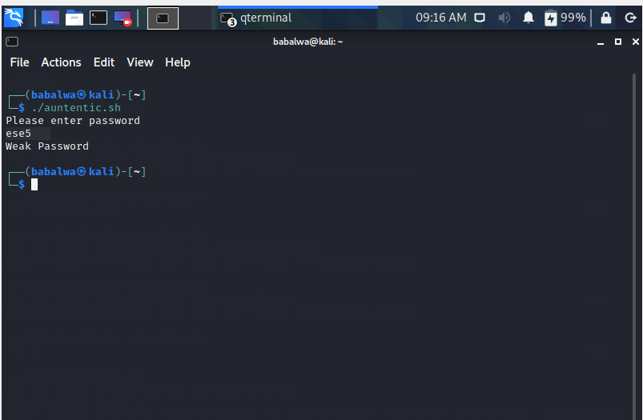I tested by entering a password that has 4 characters and the output is “Weak Password”.
* 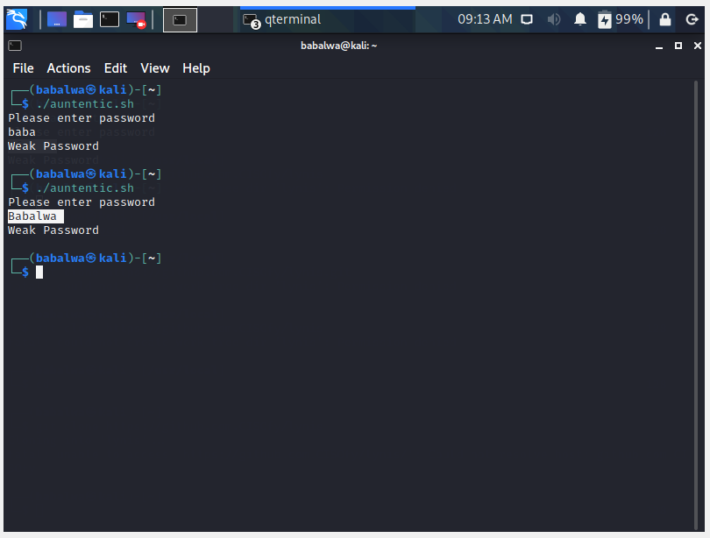I tested the password strength by entering password that have less than 8 characters.
* **I tested the password strength by entering a password that includes both alphabets and numbers.**

